Driver- Yash Mitkari

Driver-Sapna Patel

Spotter- Bhavin Patel

**Exercise 7**

**Submission:**

* Name your file as ex7.doc
* Include the source code and a screenshot of the output for each question in your word doc
* One submission is needed from each group

1. What will be displayed by the following code?

list1 = [1, 3]

list2 = list1

list1[0] = 4

print(list2)

A. [1, 3]

B. [4, 3]

C. [1, 4]

D. [1, 3, 4]

2. Write a function called **chop** that takes a list, modifies it by removing the first and last elements, and returns **None**. For example:

*>>> t = [1, 2, 3, 4]*

*>>> chop(t)*

*>>> t*

*[2, 3]*

def chop(lst):

    lst.pop(0)

    lst.pop(len(lst)-1)

    return None

t=[1,2,3,4]

chop(t)

print(t)

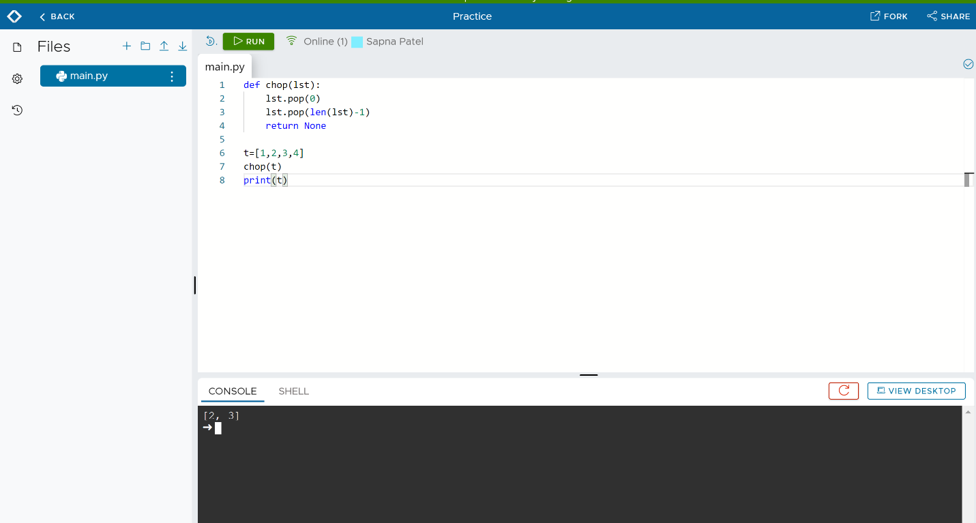

3. Write a program that reads some integers between 1 and 100 in one line and counts the occurrences of each. **Fill in the blanks.**

**Sample Run**

Enter integers between 1 and 100, inclusive: 2 5 6 5 4 3 23 43 2

2 occurs 2 times

3 occurs 1 time

4 occurs 1 time

5 occurs 2 times

6 occurs 1 time

23 occurs 1 time

43 occurs 1 time

def main():

    s = input("Enter the integers between 1 and 100: ")

    items = **s.split(" ")**# Extracts items from the string

    numbers = **[int(items) for items in items]** # Convert items to numbers

    counts = 100 * [0]

    for value in numbers:

        if value <= 100 and value >= 0:

            counts **[value - 1] += 1**+= 1

    # Display result

    for i in range(100):

        if counts[i] > 0:

            print(i + 1, "occurs", counts[i], "time" if counts[i] == 1 else "times")

main()

